SELECT * FROM task6.`cleaned_superstore data (2)`;

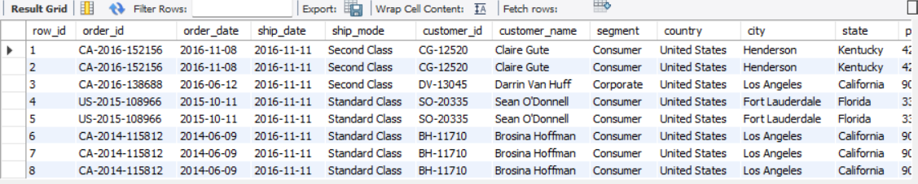

SELECT

YEAR(`order_date`) AS order_year,

MONTH(`order_date`) AS order_month,

SUM(`sales`) AS total_revenue,

COUNT(DISTINCT `order_id`) AS order_volume

FROM

`task6`.`cleaned_superstore data (2)`

GROUP BY

YEAR(`order_date`), MONTH(`order_date`)

ORDER BY

order_year, order_month;

